PF LAB PROJECT

|  |
| --- |
| TOPIC |
| BANK MANAGEMENT SYSTEM |
| GROUP MEMBERS |
| Qutaiba Zahoor |
| Muhammad Shamir |
| Umar Farooq |
| INSTRUCTOR |
| Mr. Muhammad. Imran |

|  |  |
| --- | --- |
| THE USER DEFINED FUNCTIOns: | THE BULIT IN FUNCTIONS: |
| * void search(); | * Int main() |
| * int menu(); | * to_string() |
| * void Exit(); | * system("cls) |
| * int withDraw(string Q,double L); | * exit() |
| * string getAccount(); | * open() |
| * string accountNumberGenerator(); | close () |
| * void setUserDetail(); |  |
| * void getUserDetail(string R); |  |
| * bool checkCNIC(string check); |  |
| * bool check_ph(int*); |  |
| * string getPhNo(); |  |
| * int deposit(double T,string C); |  |
| * string properCNIC(char*); |  |

How to use the application?

* To execute the program open the .exe file.
* Menu will popup on the screen.
* Select any of the option by inserting valid characters or numbers.
* No dependencies needed to download.

***SOURCE CODE***

#include <iostream>

#include <string>

#include <stdlib.h>

#include <fstream>

#include <cstdio>

using namespace std;

// ===========================================User Defined Functions

int menu();// =====================================to show menu

void Exit();// ===================================to exit program

int withDraw(string Q,double L);//============= to withdraw money

string getAccount();//=================to set account type as current or saving

string accountNumberGenerator();//==========to generate account number

void setUserDetail();//=======================input details from user

void getUserDetail(string R);//=============display user account detail

bool checkCNIC(string check);//================to check CNIC length

bool check_ph(int*);//=================check phone number length and validity

string getPhNo();//=========================input phone number from user

int deposit(double T,string C);//===========deposit amount in an account

string properCNIC(char*);//=======================make CNIC proper

string setCNIC();//=============================input CNIC from user

void search();//=====================================search a user

//Main function

int main(){

system("cls");//built in function to clear screen

menu();//function call for menu()

}

//Function to generate account number for new user

string accountNumberGenerator(){

static int n = 0 ;

++n ;

string str = "0000000000000" + std::to_string(n);//converting int to string by using built in function to_string()

return str;

}

//function for account creation .......gets details of user

void setUserDetail(){

system("cls");

//input cnic

string cnicname=setCNIC();

string files=cnicname+".txt";

ofstream file(files,ios::app);

file<<"CNIC_Number===>"<<cnicname;

file<<'\n';

//input first name

string name;

cout<<"\nEnter your first name : ";

cin>>name;

file<<"First_Name===>"<<name;

file<<'\n';

//input last name

cout<<"Enter your Last name : ";

cin>>name;

file<<"Last_Name===>"<<name;

file<<'\n';

//input phone number

string phoneNumber=getPhNo();

file<<"Phone_Number===>"<<phoneNumber;

file<<'\n';

//account type

string acc=getAccount();

file<<"Account_Type===>"<<acc;

file<<'\n';

//setting gender

while(true){

int gender;

cout<<"Enter your gender : \n 1.Male \n 2.Female";

cin>>gender;

if(gender==1)

file<<"Gender===>Male";

else if(gender==2)

file<<"Gender===>Female";

else

{

cout<<"Enter a valid gender ";

continue;

}

file<<'\n';

break;

}

//set Date Of Birth

while(true){

int dob1,dob2,dob3;

cout<<"Enter your date of birth : ";

cout<<"Enter day : ";

cin>>dob1;

if(dob1>31 || dob1<1){

cout<<"Enter a valid day ";

continue;

}

cout<<"Enter month : ";

cin>>dob2;

if(dob2>12 || dob2<1){

cout<<"Enter a valid month ";

continue;

}

cout<<"Enter year (1920-2004): ";

cin>>dob3;

if(dob3>2004 || dob3<1920){

cout<<"Enter a year within given range ";

continue;

}

file<<"Date_Of_Birth===>"<<dob1<<"/"<<dob2<<"/"<<dob3;

file<<'\n';

file<<"Account_Number===>"<<accountNumberGenerator();

file<<'\n';

break;

}

//initializing account balance as 0.00

file<<"Current_Balance===>\n";

file<<0.00;

file.close();

double balance=0.000;

int check;

//asking to deposit money

cout<<"Your initial balance is : "<<balance<<" To deposit money in your account press 1 .....to continue press any other key : ";

cin>>check;

//using if to check selected option

if(check==1){

cout<<"Enter amount to deposit : ";

cin>>balance;

deposit(balance,cnicname);//function call for deposit()

}

}

//Function to check CNIC

bool checkCNIC(string check){

if(check.size()!=15)

return false;

else

return true;

}

//Function to make CNIC proper

string properCNIC(char* a){

char temp[15];

for(int i=0;i<15;i++){

if(i==5){

temp[i]='-';

continue;

}

if(i==13){

temp[i]='-';

continue;

}

if(i>13)

{

temp[i]=a[i-2];

continue;

}

if(i>5)

{

temp[i]=a[i-1];

continue;

}

temp[i]=a[i];

}

string final=temp;

return final;

}

//Function to input CNIC

string setCNIC(){

string proper;

while(true){

char CNIC[13];

cout<<"Enter your CNIC (dont include hyphen): ";

cin>>CNIC;

proper=properCNIC(CNIC);

if(!(checkCNIC(proper))){

cout<<"please Enter Proper CNIC";

continue;

}

else

break;

}

string fileName=proper;

return fileName;

}

//Function to search a user

void search(){

system("cls");

cout<<"Enter CNIC of person : (include hyphens) : ";

string find;

cin>>find;

find=find+".txt";

ifstream f;

f.open(find);

string getDetail;

int l=0;

while(l<3){

cout<<"------------------------------------------\n";

f>>getDetail;

cout<<getDetail;

cout<<endl;

l++;

}

cout<<"\n The restof the detail is confidential \n";

}

//Function to exit the program

void Exit(){

system("cls");

cout<<" --------THANK--------\n ----YOU---- \n --------VERY MUCH--------\n";

exit(0);

}

//Function to deposit money and updating money details

int deposit(double T,string C){

C=C+".txt";

ifstream read(C);

string arr[9];

int amount;

int i=0;

while(read){

if(i>8){

read>>amount;

}

else

read>>arr[i];

i++;

}

amount=amount+T;

read.close();

ofstream update;

update.open(C);

i=0;

while(i<=9){

if(i>8)

update<<amount;

else

update<<arr[i]<<'\n';

i++;

}

update.close();

//updateBalance(C,T);

cout<<"\n Successfully added \n";

}

//Function to check phone number

bool check_ph(string ph){

string temp=ph.substr(0,2);

if(temp!="03"){

cout<<"Please enter a number that starts with 03 ";

return false;

}

else if(ph.size()!=11){

cout<<"Please enter a number containing 11 letters ";

return false;

} else

return true;

}

string getPhNo(){

string Ph_No;

while(true){

cout<<"Enter your Ph-No : ";

cin>>Ph_No;

if(!check_ph(Ph_No)){//calling function to check phone number validity

continue;

}

else{

break;

}

}

return Ph_No;

}

//Function to get account type

string getAccount(){

int type;

string type1="current";

string type2="saving";

cout<<"Enter your account type \n 1. current \n 2. savings ......(press either 1 or 2)";

cin>>type;

if(!(cin)>>type)

return getAccount();

else if(type==1){

return type1;

}

else if(type==2){

return type2;

}

else{

cout<<"Please enter a valid option ";

return getAccount();

}

}

//Function to display menu

int menu(){

cout<<" WELCOME ";

cout<<"\nPress the corresponding number to select your operation \n";

cout<<"1.Create account\n2.Search a user\n3.Deposit money\n4.Withdraw money\n5.See Your account Details\n6.Exit\n ------------ : ";

int option;

string acc;

string s;

double amn;

cin>>option;

switch(option){//Switch cases to call the specified function

case 1:

setUserDetail();

cout<<"Press 1 to continue to main menu......any other key to exit : ";

cin>>amn;

if(amn==1)

return main();

else

exit(0);

case 2:

system("cls");

cout<<"Enter cnic number to search a user :";

search();

cout<<"Press 1 to continue to main menu......any other key to exit : ";

cin>>amn;

if(amn==1)

return main();

else

exit(0);

case 3:

system("cls");

cout<<"Enter amount to deposit ";

cin>>amn;

cout<<"Enter CNIC number of account holder ";

cin>>s;

cout<<"Enter account number ";

cin>>acc;

deposit(amn,s);

cout<<"Press 1 to continue to main menu......any other key to exit : ";

cin>>amn;

if(amn==1)

return main();

else

exit(0);

case 4:

system("cls");

cout<<"Enter your CNIC : ";

cin>>s;

cout<<"Enter amount to withdraw : ";

cin>>amn;

if(withDraw(s,amn)){

cout<<"Successfully Withdrawn \n";

}

cout<<"Press 1 to continue to main menu......any other key to exit : ";

cin>>amn;

if(amn==1)

return main();

else

exit(0);

case 5:

system("cls");

cout<<"Enter CNIC Number : ";

cin>>s;

getUserDetail(s);

cout<<"Press 1 to continue to main menu......any other key to exit : ";

cin>>amn;

if(amn==1)

return main();

else

exit(0);

case 6:

Exit();

break;

default:

system("cls");

cout<<"please select a valid option ";

cout<<"Press 1 to continue to main menu......any other key to exit : ";

cin>>amn;

if(amn==1)

return main();

else

exit(0);

}

}

//Function to display user account detail

void getUserDetail(string R){

string print;

string file=R+".txt";

ifstream get(file);

while(get){

cout<<"\n------------------------------------------\n";

get>>print;

cout<<print;

}

}

//Function to withdraw money from account and updating money details

int withDraw(string Q ,double L){

Q=Q+".txt";

fstream read_file(Q);

string arr[9];

int amount;

int i=0;

while(read_file){

if(i>8){

read_file>>amount;

}

else

read_file>>arr[i];

i++;

}

if(amount<L){

cout<<"Low Balance ..............";

return main();

}

amount=amount-L;

read_file.close();

ofstream update;

update.open(Q);

i=0;

while(i<=9){

if(i>8)

update<<amount;

else

update<<arr[i]<<'\n';

i++;

}

return 1;

}

***OUTPUTS***

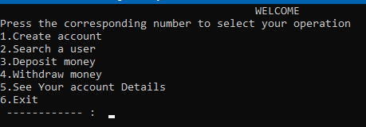

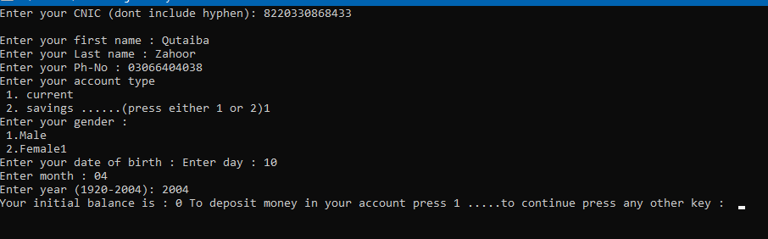

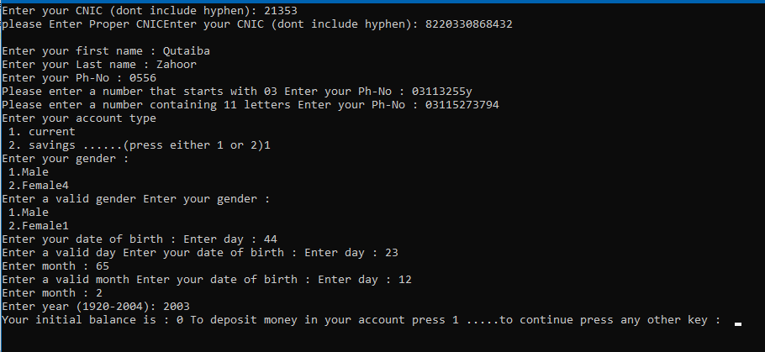

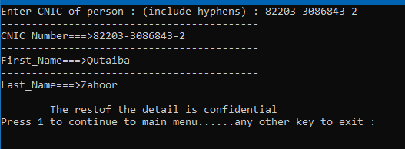

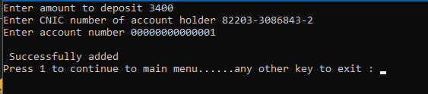

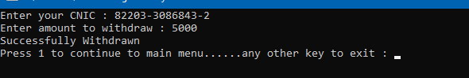

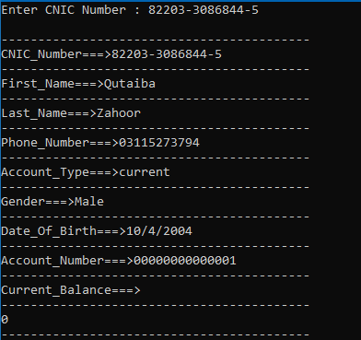

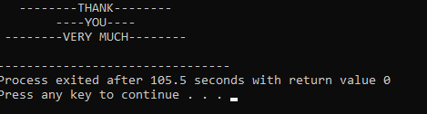

***FILES***

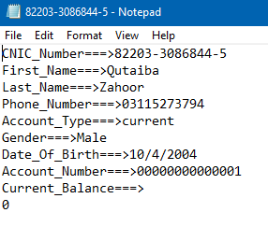

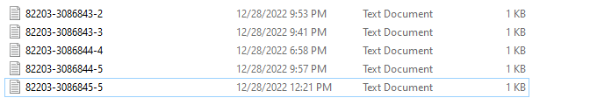

ALL ACCOUNTS CREATED ARE STORED AS SEPARATE FILES